Motor Tuning in Power PMAC

Pre-requisitions: the encoder, motor and amplifier parameters have been configured properly.

# Current Loop Tuning

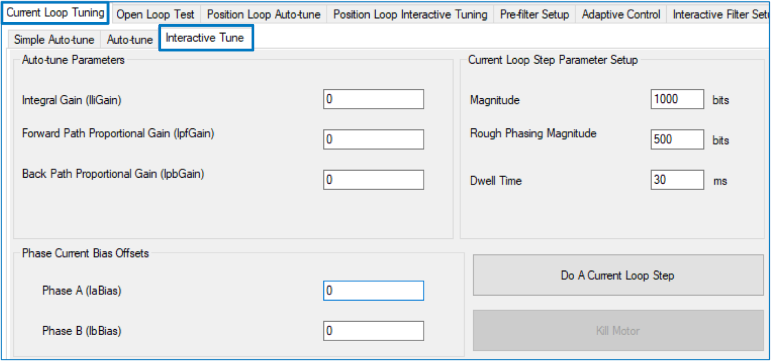

## Get started

* Motor[].I2TSet / 2 > Magnitude < Motor[].I2TSet
  + Motor[].I2TSet is, theoretically, the current magnitude (in ADC bits) which the motor could withstand continuously without overheating. It is Ixx57 in Turbo PMAC.
* Motor[].I2TSet / 2 > Rough Phasing Magnitude < Motor[].I2TSet
* 20 > Dwell Time < 100
* IiGain conservative start = 0.1
* IpfGain conservative start = 10 * IiGain

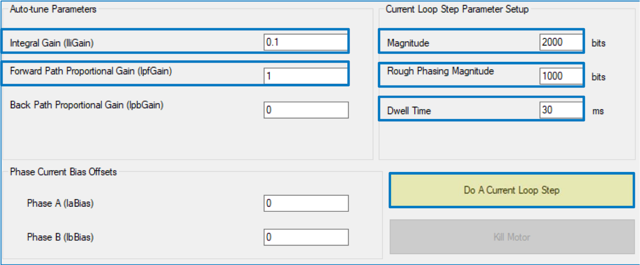

## Procedure

The goal is to superimpose the actual current step on top of the commanded magnitude.

* Natural frequencies in the 300 – 600 Hz with a rise time of about 1 msec are adequate for most applications. Typically, this is limited by the resistance and inductance of the motor (electrical time constant), but also cabling length and quality. Higher performance (e.g. linear) motors could easily achieve frequencies greater than 1 KHz
* IiGain can be thought of as the transient effort
* IpfGain can be thought of as the damping effort
  + Increase both IiGain to improve the rise time
  + Adjust IpfGain to control the damping effect and increase the natural frequency

## Current Loop tuning tips

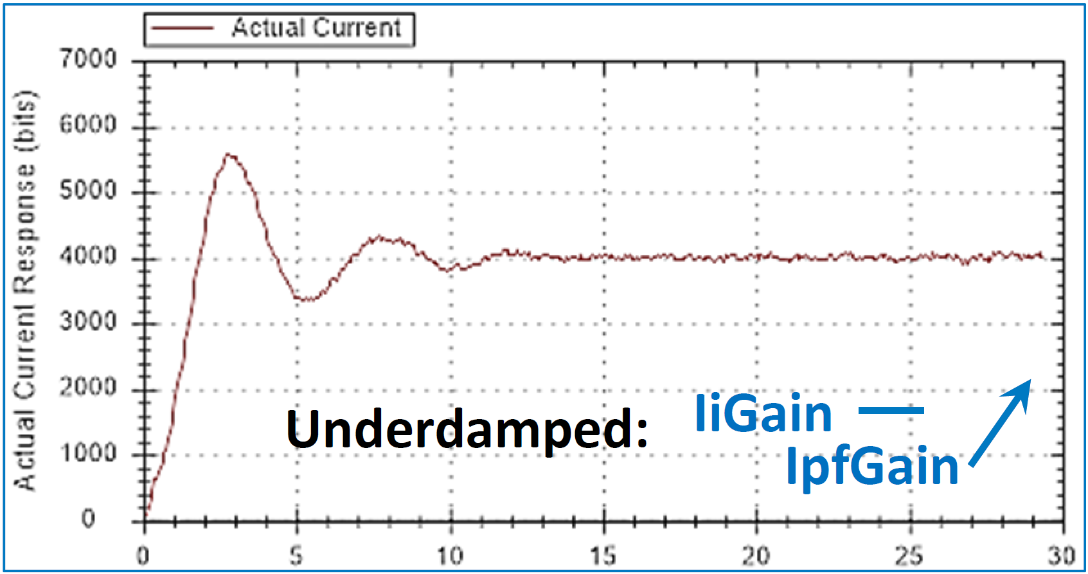

**Rise Time: 1.43msec Natural Frequency: 142 Hz Damping Ratio: 0.288**

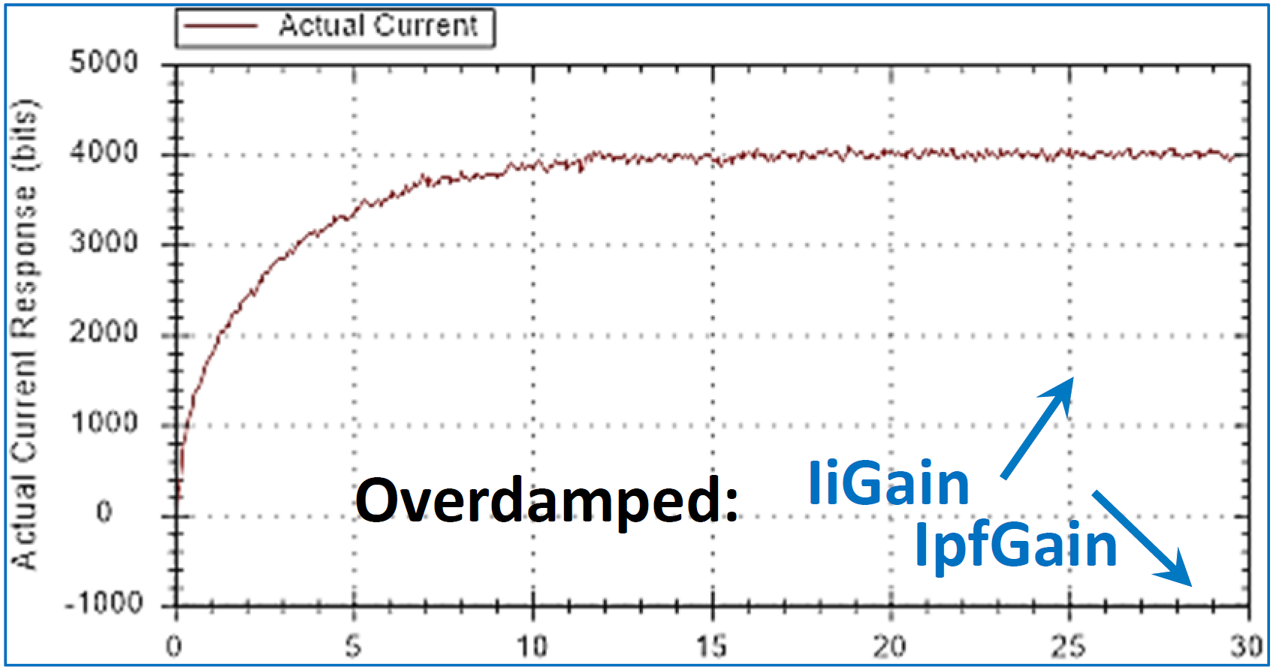

**Rise Time: 6.43 msec Natural Frequency: 86.53 Hz Damping Ratio: 1.00**

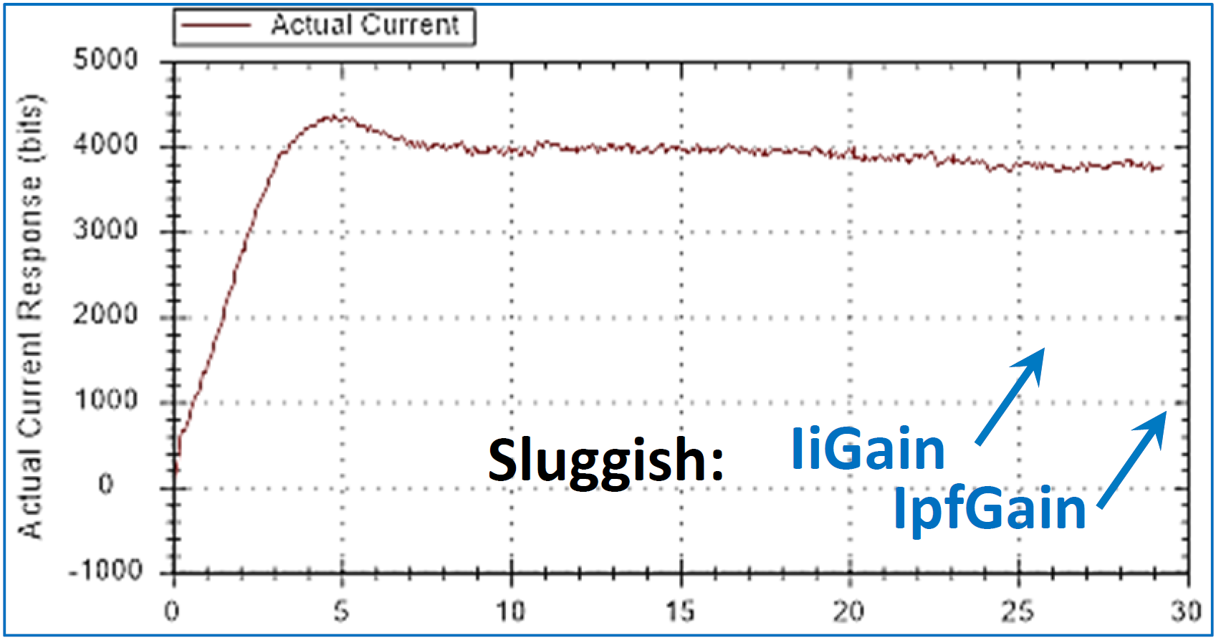

**Rise Time: 2.5 msec Natural Frequency: 105 Hz Damping Ratio: 0.5**

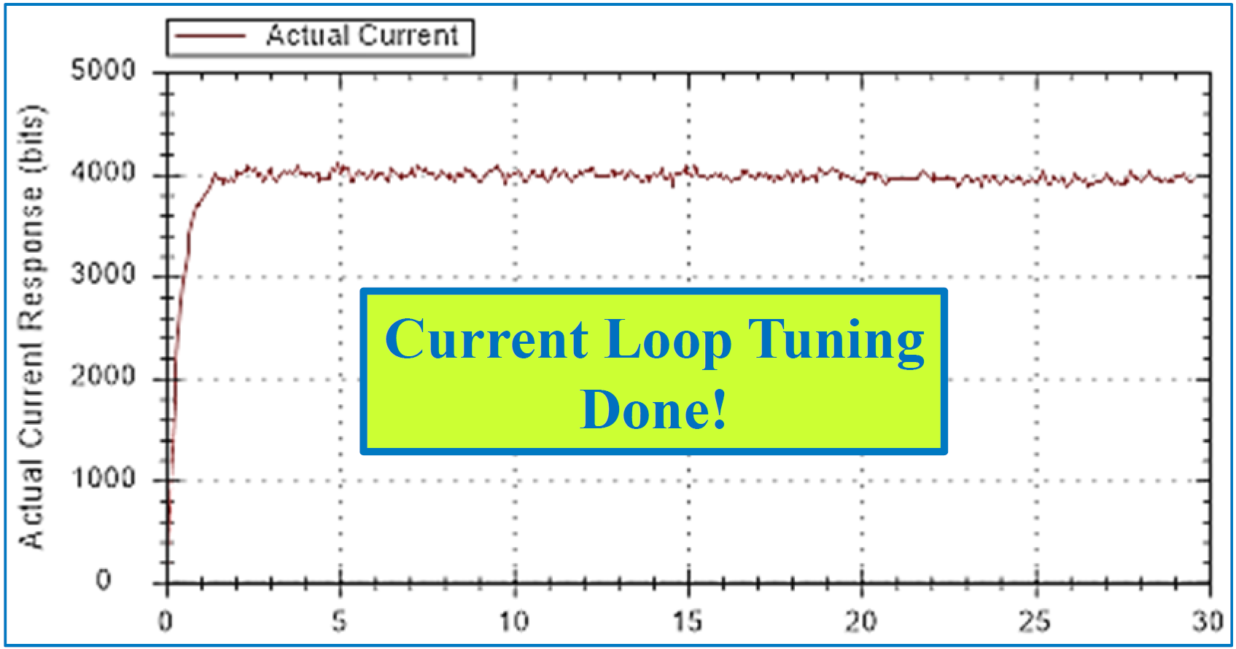

**Rise Time: 0.7 msec Natural Frequency: 530 Hz Damping Ratio: 0.75**

# Open Loop Test

The open loop test serves as a tool to verify that the encoder is counting in the same direction as the command output. The goal is to obtain positive movement (velocity) when a positive (open loop) command is issued, and vice‐versa. Automatic open loop test (step) using the IDE (recommended)

* Start with a conservative % output (~3 – 5)
* Start with a conservative test time (~100 msec)
* 2 repetitions (typical) will produce a saw tooth
  + repetition is often used due to limited travel

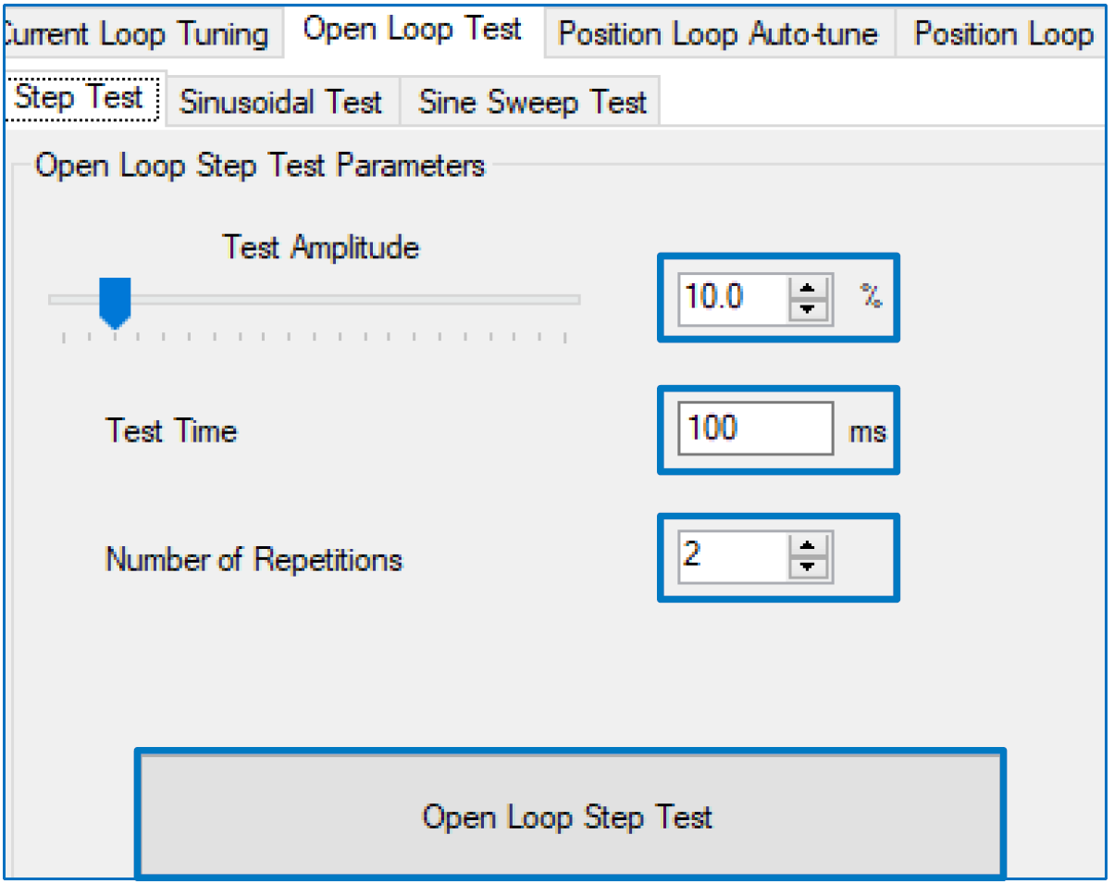

Manual procedure e.g.

* #1OUT1, is the motor moving positive?
* #1OUT-1, is the motor moving negative?
  + Looking at position/velocity window
  + #1K to kill immediately!
  + Can increase output percentage as needed

If the test fails or shows an inverted saw tooth

* For analog amplifier (brushed motor)
  + IF quadrature, sinusoidal, or resolver
    - Change decode: ACC24E3[].Chan[].EncCtrl = 7 | 3
  + ELSE, Swap DAC leads (going to the amplifier)
* o Sinewave commutation (brushless motor)
  + IF quadrature, sinusoidal, or resolver
    - Change decode: ACC24E3[].Chan[].EncCtrl = 7 | 3
  + ELSE, Swap 2 of the motor leads (at the amplifier side)
    - Not amplifier signal leads from the ACC-24E3
* Direct digital amplifier (brushless motor)
  + IF quadrature, sinusoidal, or resolver
    - Change decode: ACC24E3[].Chan[].EncCtrl = 7 | 3
  + ELSE, Swap 2 of the motor leads (at the amplifier side)
  + Either change requires re-phasing the motor
  + If problem persists, double check Motor[].PhasePosSf



# Position Loop Tuning

## Auto-tuning

Use Auto-tune to produce the primary gains (Kp, Kvfb) before find interactive tuning.

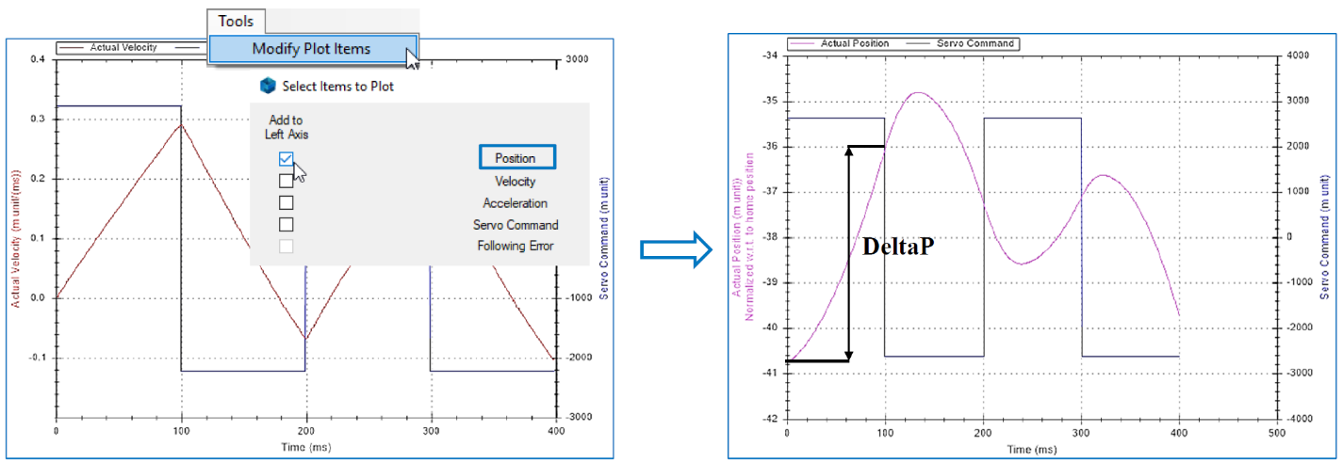

### **Simple Auto-Tune**

* Choose amplifier type
  + Torque for most analog amplifiers (brushed motors)
  + Direct PWM for digital direct PWM motors (brushless motors)
  + Sinusoidal for sinewave commutated amplifiers (typically brushless motors)
  + Velocity for velocity mode amplifiers (rarely used with the ACC-24E3)
* Start with lower performance (slide bar)
* Encoder resolution
  + If Motor[].PosSf = 1; Enter counts per motor units
  + If Motor[].PosSf ≠ 1 (already scaled); Enter 1
* Enter Min. Travel; 0 is acceptable
* Enter Max. Travel; delta position from automatic open loop test
  + For manual open loop test users; 1-10 mm for linear motors, 5 – 30 degrees for rotary motors

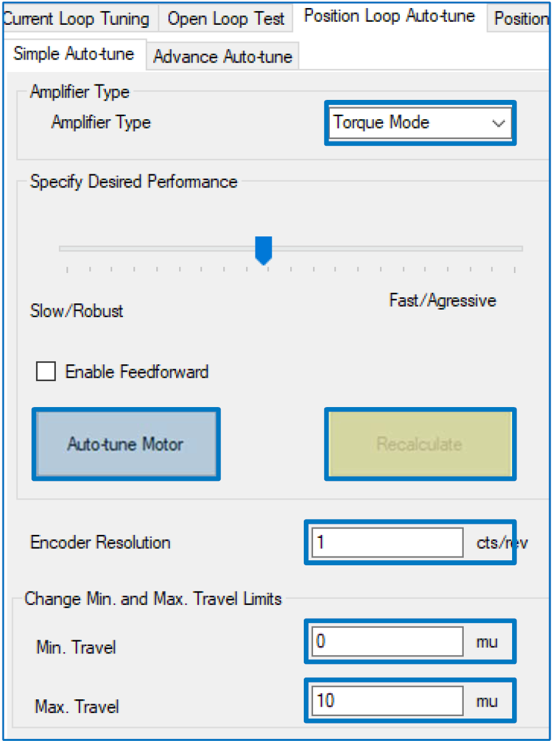

### **Advanced Auto-Tune**

Procedure

* Choose amplifier type
  + Same as simple auto-tune
* Use same excitation magnitude and time as successful open loop test
* Start with a conservative bandwidth (e.g. 10 – 20 Hz) and damping ratio (e.g. 0.7)
* Enter Max. Travel; delta position from automatic open loop test
  + For manual open loop test users; 1-10 mm for linear motors, 5 – 30 degrees for rotary motors

➢ Perform an auto‐tune

* Implement gains, and check with a step move response (interactive tuning).
* Continue with interactive (fine) tuning, or come back and recalculate for higher bandwidth.

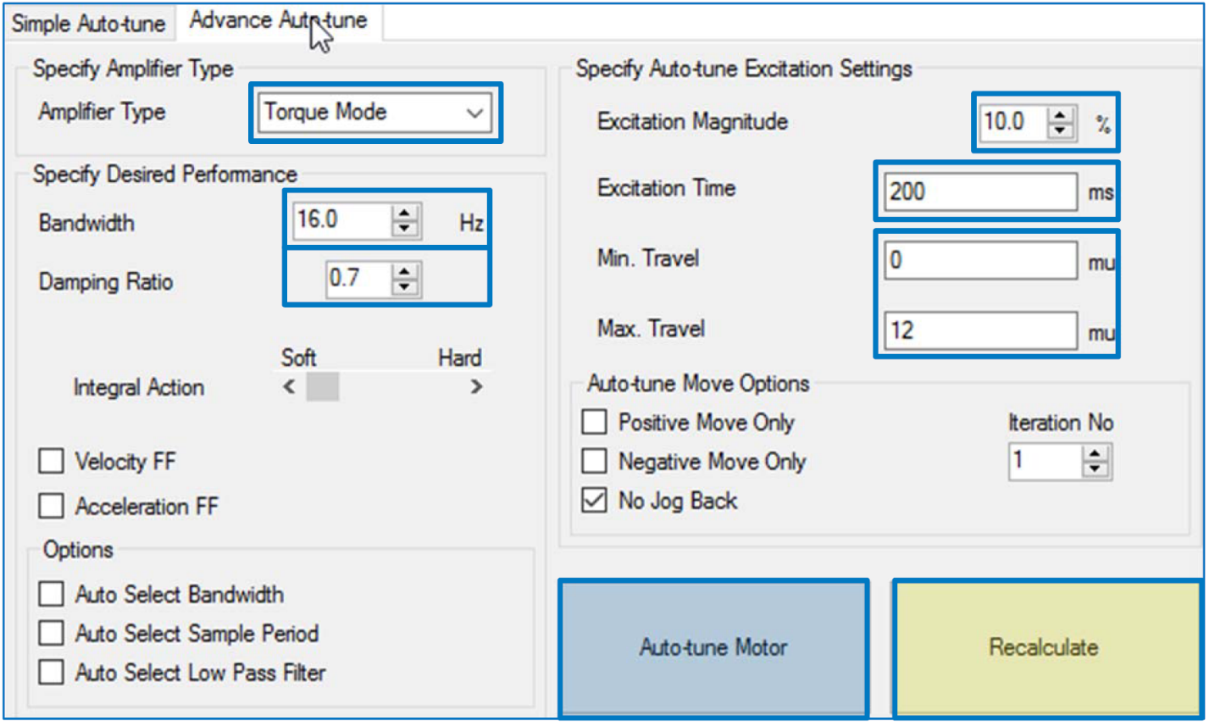

## Step Move

The goal of the step move is to “superimpose” the actual position on top of the commanded “step” position by optimizing the proportional Kp, and derivative Kvfb gains, which result in the highest possible bandwidth (natural frequency). These two core gains typically drive the level of performance in (positioning) servo control. Their values depend on the feedback resolution, servo update rate, type of motor, and coupling mechanics.

* Fastest rise and settling times
* Lowest overshoot with the best damping ratio (0.7 – 1.0)

The step move is an impulse which excites the system (with its load). Typical step move sizes at the load:

* 0.1 to 0.5 mm or 0.040 – 0.200 inches (depending on the resolution) for linear or “geared rotary” motors.
* 5 – 10% of a revolution for standard rotary motors.

Move times vary from 200-300 msec to up to 2000 msec depending on the inertia, responsiveness of the system, and allowed jerk.

No integral gain Ki or any other gain should be used during a step move.

### **Preparation**

Set the fatal following error limit to be larger than the step move size.

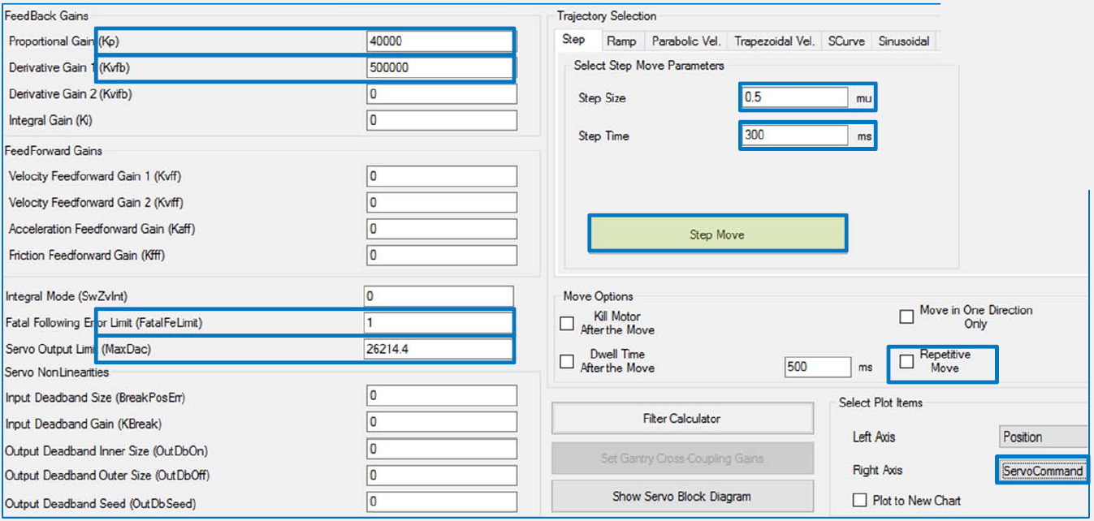

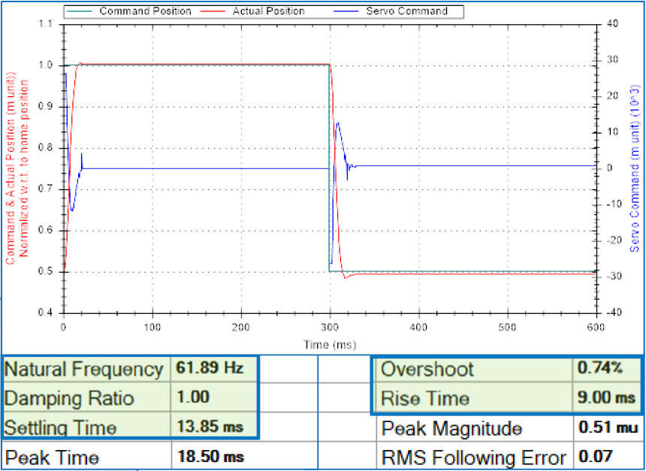

### **Procedure**

* Adjust Kp (to increase the servo cmd effort) and Kvfb (maintaining overshoot < 10%) simultaneously until one of the following conditions becomes true:
  + Servo command output is ~ 40-50% with acceptable stiffness (properly – or over–sized motor to load)
  + Servo command output is saturated 100%
    - 2-3 msec saturation, in some systems, is acceptable (under–sized motor to load)
* Excessive vibration or servo command noise
  + Is this the limitation of the mechanical / actuator assembly?
  + Typically, these cases require advanced troubleshooting expertise and deep knowledge of the system.
* Adjust Kvfb for 0.7‐1.0 damping ratio

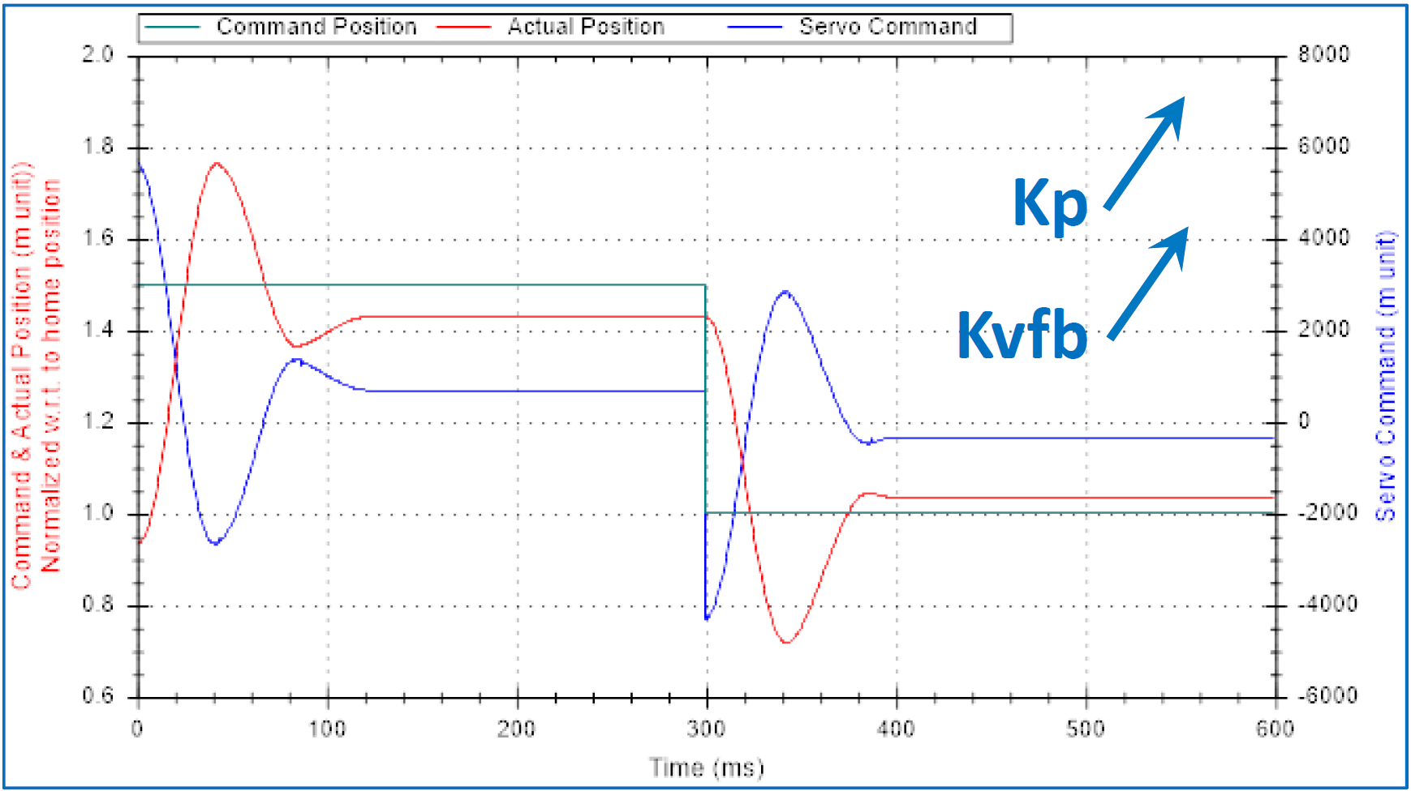

Max. **Servo cmd** about **15%** of MaxDac

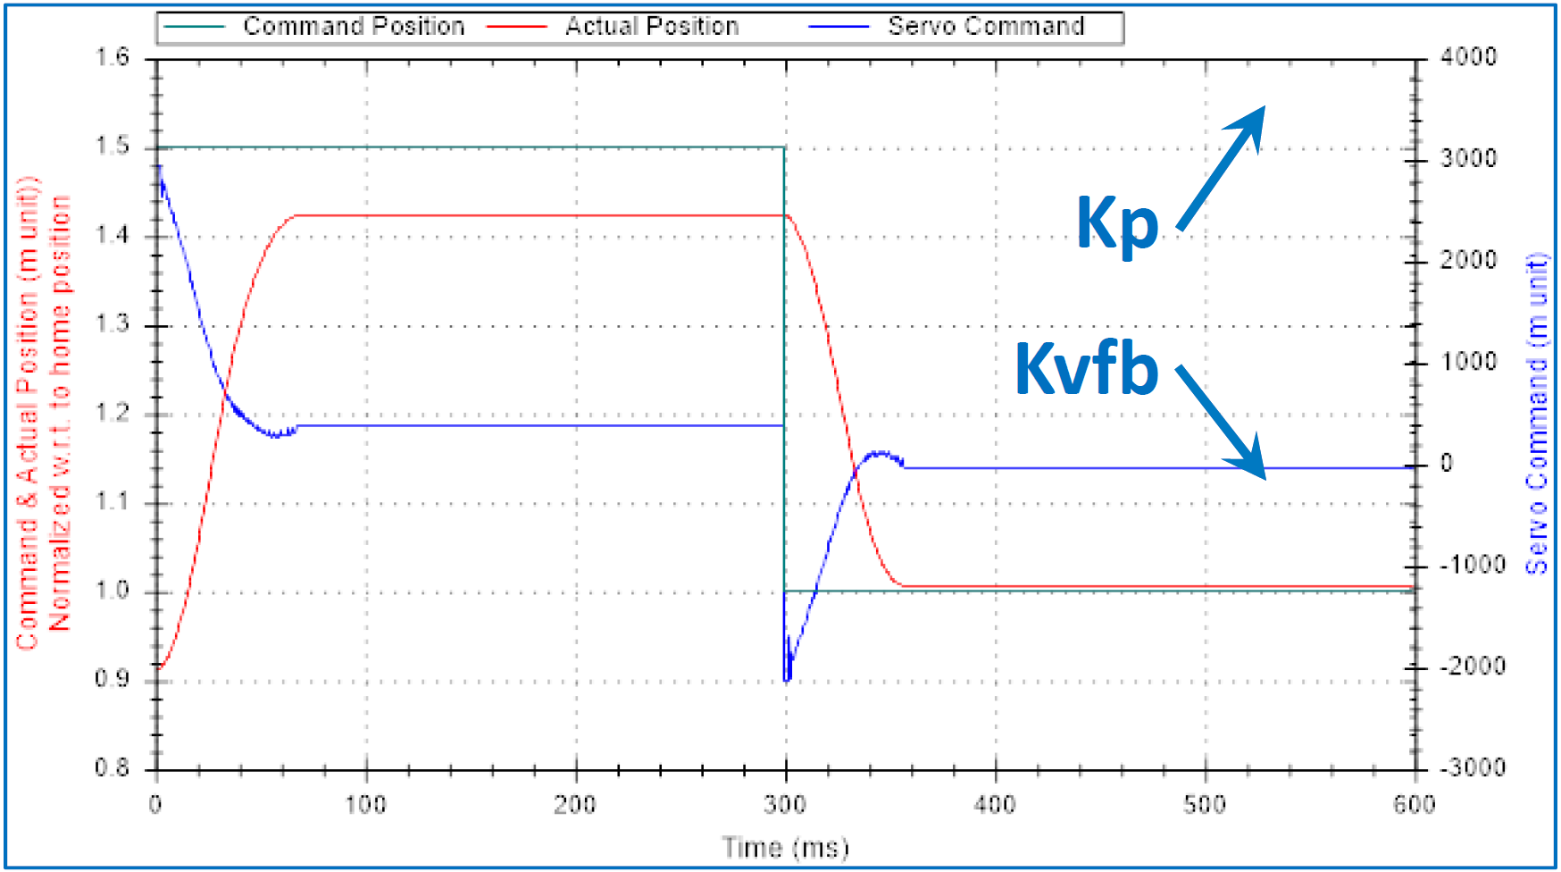

Max. **Servo cmd** about **10%** of MaxDac

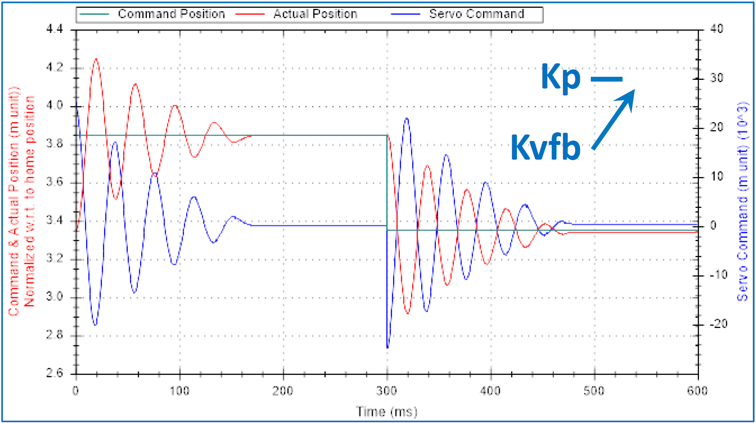

Max. **Servo cmd** about **90%** of MaxDac

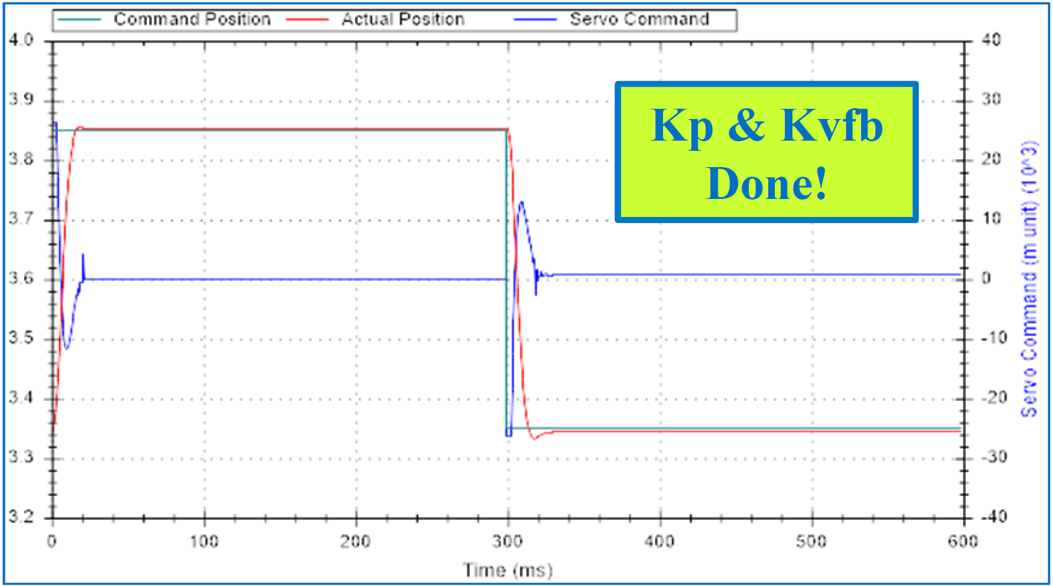

Max. **Servo cmd** at **100%** of MaxDac, 1 msec

## Parabolic Move

The goal of the parabolic move is to optimize the feedforward (and integral) gains. The feedforward gains complement the core gains in order to minimize following error during motion. The integral gain Ki, minimize error also during moves, but also drive the step and settle responsiveness.

The parabolic move is a velocity-time profile.

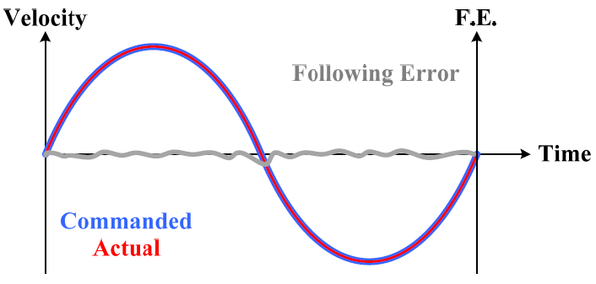

* Typical move sizes at the load
  + 10 to 40 mm or 25 – 100 inches (depending on the resolution) for linear or “geared rotary” motors
  + 1 – 4 revolutions for standard rotary motors
* Move times vary from 600 msec to up to 2000 msec depending on the inertia, responsiveness of the system, and allowed jerk
  + You do want to get up to at least about 30% of the maximum anticipated axis velocity
* The basic gains deduced from parabolic move tuning:
  + Velocity feedforward Kvff
  + Acceleration feedforward Kaff
  + Integral gain
  + Friction feedforward (less common)

### **Preparation**

* Rule of thumb: start with Kvff = Kvfb
* Choose size and move time
* Test once
* Check repetitive move if safe and no errors
  + Change gains on the fly and watch the effects
* Recommended order of gain optimization
  + Acceleration feedforward, Kaff
  + Velocity feedforward, Kvff
  + Integral gain, Ki
  + Friction feedforward (less common), Kfff

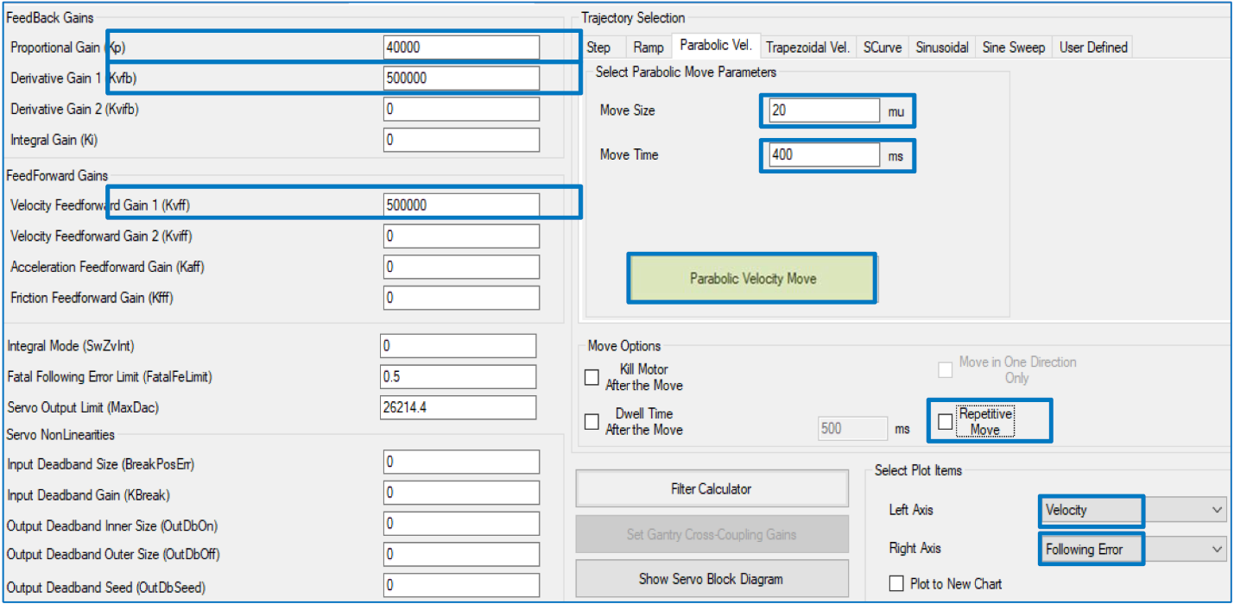

### **Optimizing Kaff**

* V–shaped following error? Increase Kaff
  + Suggested starting value ~= 5 * Kvfb
* Want horizontal F.E. lines
* Want ~0 acceleration correlation
  + Negative correlation typically means too much acceleration feedforward Kaff
* Also, notice the improved RMS following error

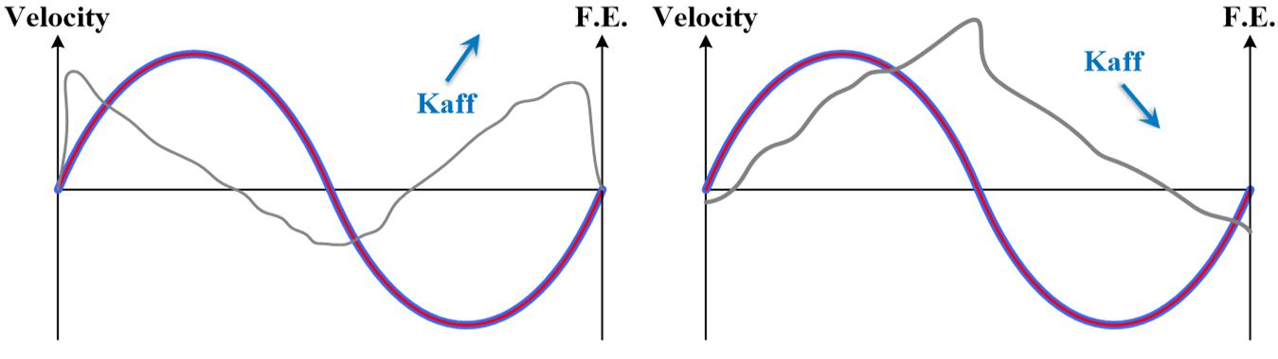

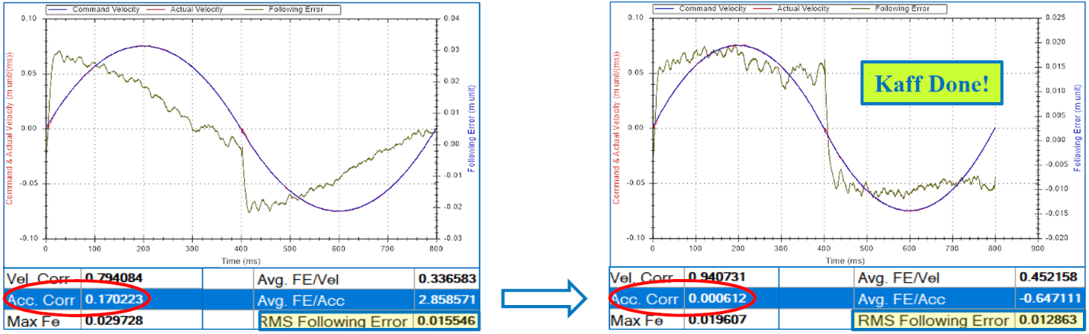

### **Optimizing Kvff**

* Step– or parabolic –shaped following error tracking
* the velocity profile? Increase Kvff
  + Suggested starting value ~= Kvfb
* Want F.E. centered about 0
* Want ~0 velocity correlation
  + Negative correlation typically means too much velocity feedforward Kvff
* Also, notice the improved RMS following error

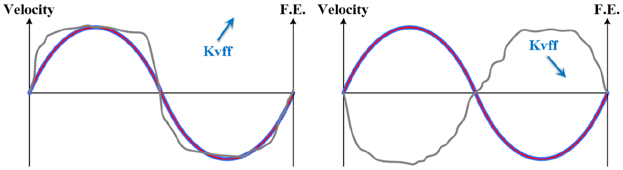

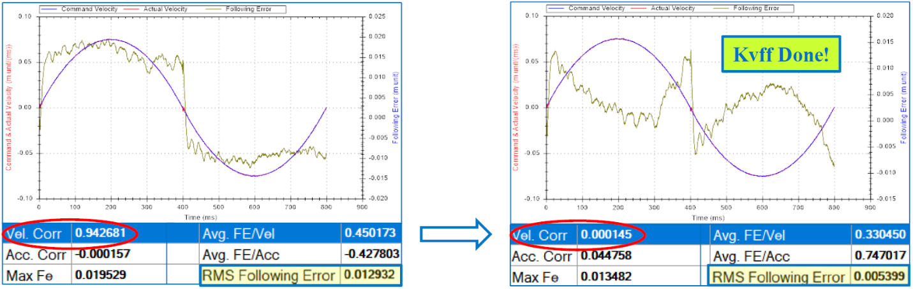

### **Optimizing Ki**

* Further decreases following error during motion and improves settling time (unwinds error quickly)
  + Suggested starting value 0.0001 or smaller
  + Typical ending values (resolution): 0.01 – 0.04
* Want uniform grouping of F.E. centered about 0
* Highest gain that keeps decreasing RMS following error without ill-effects (oscillation) in F.E. data
* Watch for F.E. scale. Increasing Ki while within the resolution limitation (LSB) could have counter effects

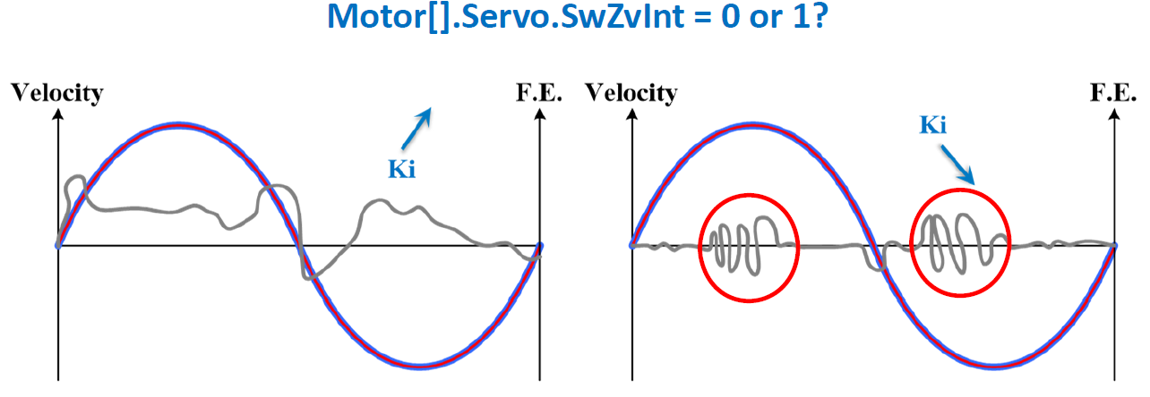

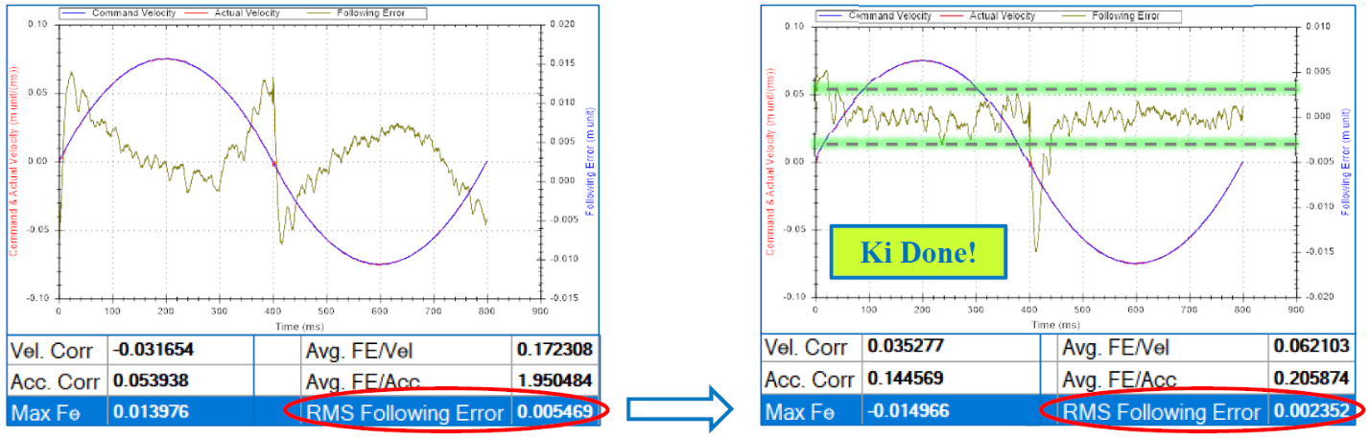

### **Optimizing Kfff**

* Do NOT be aggressive (tune-happy) or use Kfff at all if you do not have “real” friction
* Kfff (or too high of) in absence of friction may cause motor knocking (counter) during acceleration
* Alleviates following error at acceleration and direction reversals due to friction
  + Suggested starting values 5 – 50
* Want to eliminate (or split in half) F.E. Accel and reversal spikes

# Tuning Final Thoughts

* Motor[].MaxDac
  + In all tuning cases, MaxDac is the ultimate servo effort reference
  + MaxDac must be computed accordingly before any servo tuning
* Motor[].Servo.MaxPosError
  + Increases max servo cmd allowed (e.g. higher resolution encoders)
* Motor[].Servo.MaxInt
  + Limits the magnitude of the integrated position error
* Motor[].Servo.Kvifb, and Motor[].Servo.Kviff
  + Added to the control effort before the integrator, meaning that the integrator is also acting on the velocity error
  + Rarely used, but could be better at rejecting disturbances in a dual feedback system
* Motor[].Servo.BreakPosErr, Motor[].Servo.Kbreak
  + True deadband
    - E.g. dither due to gearing, or synthesized loop(s)
  + Gain multiplier
    - Need more “in-position” stiffness and have the resolution for it?
    - Could cause instability!

